**MARTHOLME GREENWAY – HERITAGE BACKGROUND**

**(With many thanks to Brian Jeffery, local historian for his assistance)**

The site was originally acquired by LCC from North West Water and landscaped in 1995.

Lancashire & Yorkshire Railway constructed Martholme viaduct, a Grade II listed sandstone structure, to take the North East Lancashire loop line over the River Calder. It was completed in 1877. This line operated between Great Harwood and Simonstone and was built to serve Martholme Colliery and the mills of Great Harwood and Padiham. The line closed in 1964.

**Early History**

Martholme Manor and Estate was the seat of the Hesketh family from around 1577 with the estate being known as “The Leeches” and now known locally as “Harwood Bar”. The present house is the oldest building in Great Harwood. A previous house occupying the site dates back to 1177 and the site had a surrounding moat.

**Mining History**

The Heskeths, while still having mining rights, issued leases to extract coal from their estate from 1661 until 1848. These coal pits were worked mostly by the Lomax family of Clayton Hall who mined Cop Meadow in 1786. Some shafts were worked by the Taylors, Forts, Birtwistles, Rippons and Barlows.

Martholme, or Cock Pit or Cop Colliery, as it was also known, was situated 175 metres East of Cop Hall at the junction between A680 and Martholme Lane. The colliery worked the Upper and Lower Mountain Mines with the deepest shaft being 210 yards (192m).

In 1805, the Heskeths sunk 3 shafts in Great Harwood. They sold most of their estate to James Lomax but retained the mining rights. Martholme Colliery was started by the Hesketh family in 1844, but 2 of the 3 shafts were sold to Richard Fort of Read Hall who completed the 3 shafts at the colliery with the help of Mr Jillet, a Derbyshire mining engineer.

In 1864,ownership was transferred to the newly-formed Great Harwood Colliery Co, owned by Richard Fort, John Taylor of Morton Hall and textile manufacturers, the Birtwistle family. On 22 December 1892, Altham Colliery Co, originally created by Taylor and Rippon but now owned by James Barlow, bought Martholme colliery.

The sale was completed by Sir George W Macalpine Mech Eng, who later became the owner. In 1898 Great Harwood Colliery Co Ltd was formed as a subsidiary of Altham Colliery Co Ltd.

The mine suffered serious flooding following the miners’ strike of 1921. This in turn led to the mine being abandoned. Pumping was resumed after the strike, because all the local mines were inter-connected. Martholme Colliery was linked underground to Bridge Hey Colliery, Read, as a safety escape route. The Lower Mountain Mine was abandoned in 1927 with its owners being Altham Colliery Co (1924) Ltd. An attempt was made to re-open the Upper Mountain Mine in 1927, but this was abandoned in 1930, its owners being at that time Hargreaves Colliery Co Ltd of Burnley. With nationalisation of coal, Martholme colliery eventually became part of the National Coal Board. Pumping and ventilation was turned off in 1948.

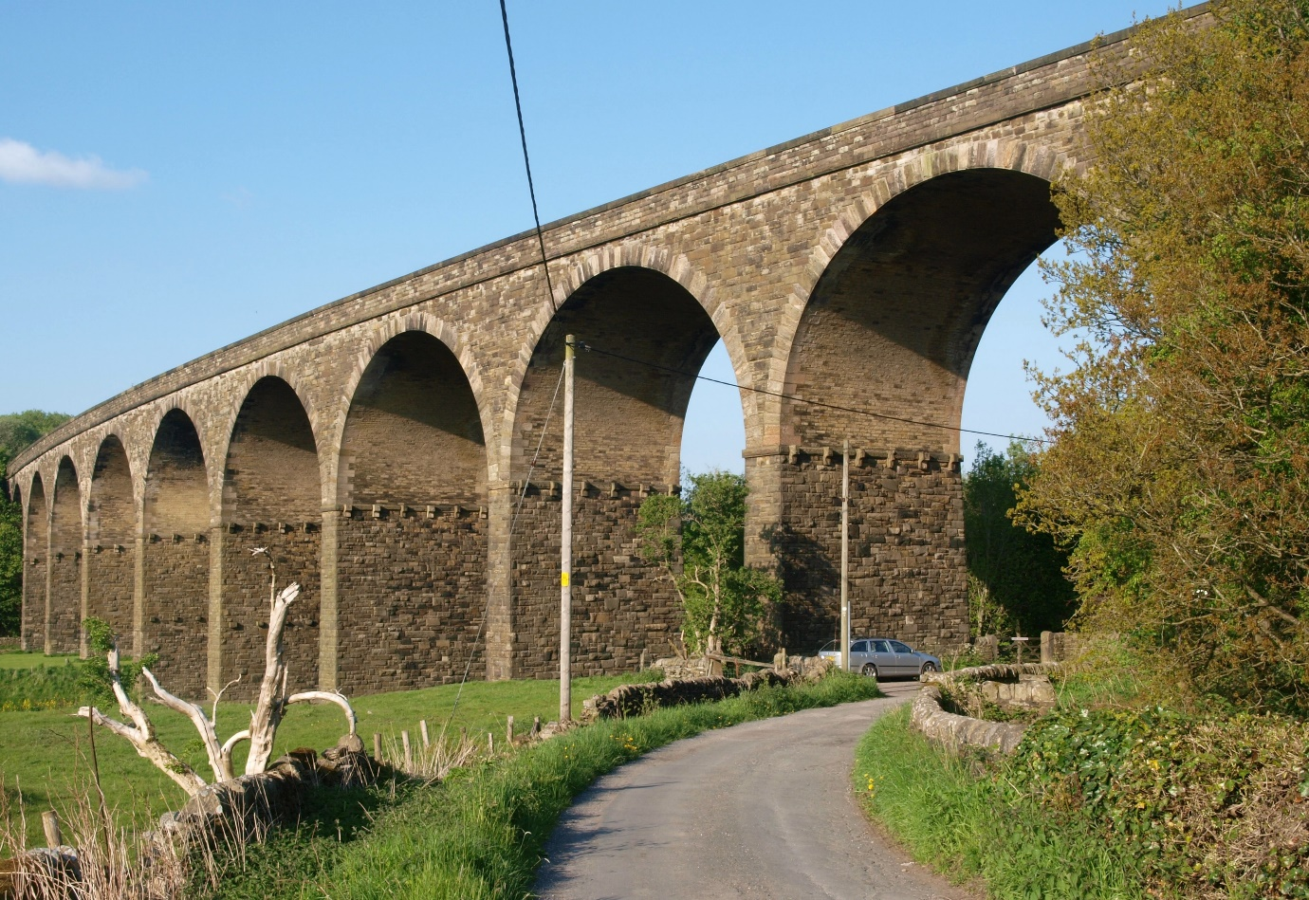

* *(Martholme Viaduct Copyright* [CC BY-SA 2.0](https://creativecommons.org/licenses/by-sa/2.0)view terms
* File:Martholme Viaduct (geograph 3695617).jpg
* Created: 25 May 2013
* [Location: 53° 47′ 59.64″ N, 2° 22′ 47.38″ W](https://geohack.toolforge.org/geohack.php?pagename=File:Martholme_Viaduct_(geograph_3695617).jpg&params=53.7999_N_2.379829_W_&language=en)

Coltsfoot rock was used for medicinal purposes by coal miners in the area, a local confectioners based in Oswaldtwistle is the world’s only supplier of the sweet:

<http://www.stockleys-sweets.co.uk/department/coltsfoot_rock>

**ABBOTT CLOUGH – HERITAGE BACKGROUND**

The site was originally acquired by LCC from a private individual and adjoins an older industrial site, now under re-development.

**Local History**

The A679 fronting the site was formerly a Turnpike road opened in 1838. There are records of a toll house for collecting tolls from users of the turnpike at Abbott Clough. Turnpikes were created to provide rapid and efficient transportation of goods and passengers between one major industrial hub and another, in this case Accrington and Blackburn. They were operated by local Trustees who were given powers to levy tolls on users for a specific stretch of road. Monies collected were then used to improve and maintain the roads.

**Local Industry**

On the adjoining industrial land a brewery was built in 1900 by the Fountain Free Brewery Co Ltd, founded in 1849. The brewery was later acquired by Thwaites Brewery in 1927 and closed shortly afterwards. The building was then taken over by Redcap Paints. Redcap platers also occupied part of the industrial area.

The name “Redcap”, commonly used by other businesses in the area derives from “Old Mother Redcap”, the name referring to an ale wife who brewed beer in beer houses, obviously distinguished by the wearing of a red cap. The Old Mother Redcap, the original brewhouse owned by Fountain Free Brewery Co Ltd stands nearby, next to the East side of the Industrial Estate.

The Old Mother Redcap Brew House before restoration. Photo source Unknown.

**WARCOCKS GREEN – HERITAGE BACKGROUND**

The site was originally acquired by LCC from Sir Robert Peel and other private individuals.

It was originally used for sand and gravel extraction for the local construction industry.

The local area is given over mainly to agriculture. Nearby Warcocks Green Farm dates from the late 1700s but a green lane running next to the property is dated to the medieval period.

**RUSHTON HOUSE FARM – HERITAGE BACKGROUND**

**Local Area History**

Pothouse Lane running close to the woodland relates to local industry as the area of Broadfield has a long association with clay potteries. A pottery and brick kiln were first documented here in 1774. During the enclosure of Oswaldtwistle Moor in this year, 15 acres of pot clay were reserved to the Lord of the Manor.

**Pottery Industry**

The local Riley and Duckworth families were instrumental in establishing the pottery industry in the local area. Holding Brothers pottery was founded in 1842 by James Holding at Gaulkthorn. In 1860 James moved the business to Broadfield. In 1900 his son Grimshaw moved it to the hillside above Oswaldtwistle where there was an abundance of clay. Grimshaw lived at nearby Broadfield House which still survives, as does Broadfield Terrace, a row of 5 cottages built by Grimshaw for each of his 5 sons.

Broadfield pottery was recorded in 1859 as having a pottery and brickworks covering 24 acres for both brown and white clay manufacturing. It continued in use until 1920 and was then demolished. Traces of clay tanks and the remainder of a reservoir can still be seen behind Broadfield garage.

**WHINNEY HILL 1 & 2 – HERITAGE BACKGROUND**

These two sites were formerly associated with the Accrington Brick and Tile Works. The land on which the previous works stood was acquired by LCC from George Armitage & Son, previous owners of the company. It was reclaimed in 1987/1989.

**Local History**

In May 1825 Whinney Hill was used as the site of a mass gathering of hand loom weavers protesting about new machinery putting them out of business. The weavers marched to Accrington to smash up weaving machinery.

**Geology**

Red fireclay known as Accrington Mudstone or shale was deposited in the area during the Carboniferous period when the Accrington area was flooded by a large lake. Fireclay is found close to coal seams.

**Local Industry**

The area had many collieries and textile mills. From 1887 world famous Accrington bricks (NORI) were produced at Whinney Hill. The local fireclay was iron hard and was used to produce strong engineering bricks that were acid resistant. It is a general belief that the name NORI was derived from IRON spelled backwards. The clay was quarried at Whinney Hill up until the 1960s. These special acid resistant bricks could be used for lining flues and chimneys. They have been used in the construction of some iconic buildings such as Blackpool Tower, the Empire State Building in New York, Sellafield Nuclear Power Station and Battersea Power Station.

The brick works had its own mineral railway line connecting with the East Lancashire line at Huncoat and was close to the Leeds/Liverpool canal, allowing easy transportation of goods countrywide.

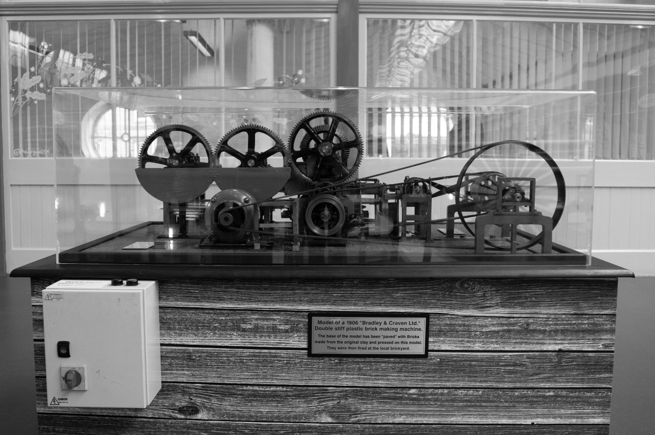

Model of the Brick Making Machine in Accrington Market Hall (above and below) Photo Credit: Jasmine Wilkinson

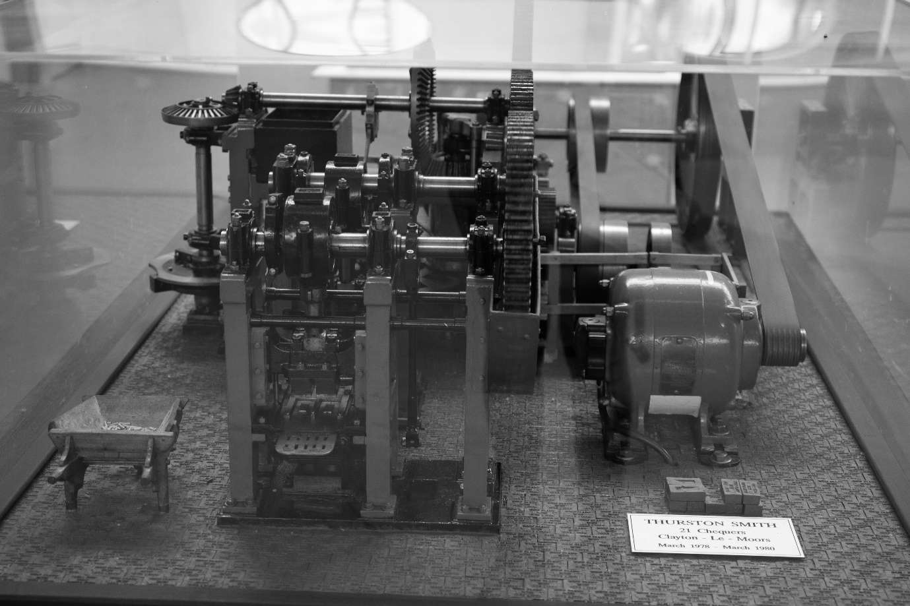

**EAST & WEST HUNCOAT – HERITAGE BACKGROUND**

These 2 woodland areas were originally acquired by LCC from NCB and CEGB.

**Local Transport**

The nearby Leeds/Liverpool canal is the longest canal in England, stretching 127 miles long with 91 locks. It took 46 years to complete and was opened in 1810. Houghton Barn Farm located alongside the canal was a canal packet station where goods were taken onboard and unloaded. The canal’s most important cargo was coal.

**Local Industry**

Coal mining was the main industry in Huncoat and Altham in the 19th and early 20th centuries. Pits were located very near to the canal and supplied coal to the industries throughout East Lancashire. The largest colliery in the area was Moorfield, situated on the site of the present day industrial site. An explosion here on 7 November 1883 claimed the lives of 68 miners.

Coal also supplied the nearby Huncoat Power Station which operated from 1952 to 1984. It has since been demolished.

Moorfield Pit Disaster memorial and Houghton Barn Farm photos below.   
Photo credit Jean Baxter.

